Lesson Plan: Ask and Answer Questions
CCSS Connections:  ELA 1 | K 1 2  With prompting and support, ask and answer questions about key details in a text. Ask and answer questions about key details in a text. Ask and answer such questions as who, what, where, when, why, and how to demonstrate understanding of key details in a text.
Materials | - Any Inspire My Kids story  - “Ask and Answer Questions” Worksheet  - Question words and anchor pictures
Duration | - Approximately 1 hour
Grade Level | - Kindergarten - 2nd

 | Activities
Objective | I will ask and answer questions about key details in a text.
Mini-lesson/ vocab  10 min. | Introduce the question words.  - Show one question word and its anchor picture. Say the word. Students repeat.  - Show a picture from the chosen article. Read and post the question that will be used today for the introduced question word (from the worksheet). Have students generate other questions that could be asked using that word and picture.  - Repeat this procedure to introduce all question words.
Practice Time  20 min. | Read the article.  - Read the article all the way through, periodically stopping to ask comprehension questions to check for understanding. This is an opportunity to discuss a particular character topic.
Discuss the article and question words.
- Show the question words and anchor pictures one at a time and discuss how to answer the questions. For variety, have students discuss the information in partners, then share with the whole class. This oral discussion will prepare students for success on their worksheet.
Watch the video or analyze the pictures.
- Each article contains a video or picture to enhance students’ understanding of the topic. Have students listen or look for information to any unanswered questions or information that can be added.
Discuss the video or pictures.
- Discuss if any information can be added to the answers previously given.
Assess  20 min. | Students answer the questions on the worksheet.  - Depending on students’ developmental level, they should answer the questions with pictures, words, or sentences, using information from the classroom conversations.
Wrap-up  10 min. | Review and Close  - Review the question words by having students read the words or say the word when they see the anchor picture.  - Review students’ answers to the questions about the article. Address any misconceptions.
Extension | Students generate other questions that could be answered using the given question words. For example, instead of asking, “What happened that’s important?” students could write, “What is the problem?” or “What happens after the main character solves the problem?” This will show students that these question words can be used to answer lots of different questions. Students could exchange papers to answer each other’s questions.
Ask and Answer Questions
Name ____________________________________ Date _________________________
Use pictures, words, or sentences to answer the following questions about the article.
 | Who is this mostly about?
 | What happened that’s important?
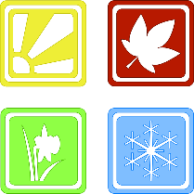 | When did this happen?
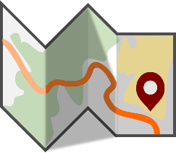 | Where did this take place?
 | Why did this happen?
 | How did this happen?

 | Who
 | What
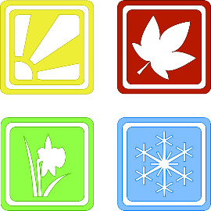 | When
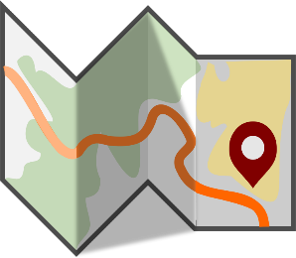 | Where
 | Why
 | How
Question Words and Anchor Pictures

