Lesson Plan: Go Back to the Text
CCSS Connections:  ELA 1 | 3 4 5  Ask and answer questions to demonstrate understanding of a text, referring explicitly to the text as the basis for the answers. Refer to details and examples in a text when explaining what the text says explicitly and when drawing inferences from the text. Quote accurately from a text when explaining what the text says explicitly and when drawing inferences from the text.
Materials | - Any Inspire My Kids story  - “Go Back to the Text” Worksheet prepared with two questions from the article  - “Go Back” song lyrics (and Beetles’ “Get Back!” song, if desired)  - Sample paragraph about volcanoes
Duration | - Approximately 70 minutes
Grade Level | - 4th-5th NOTE: The 3rd grade standard is more like the 2nd grade standard. Check out the K-2 lesson plan.

 | Activities
Objective | I will refer to details and examples to explain what happened in the text.
Mini-lesson/ vocab  15 min. | Introduce the concept of going back to the text.  - Teach the “Go Back!” song. Explain that today they will go back to the text to find the answer.  - Display the simple paragraph for students to see. Ask a question about the text. Sample questions:  - How is a volcano different than a regular mountain?  - When does an eruption occur?  - Why can lava flow be a fire hazard?  - After a student gives an answer, ask, “How do you know?”  - Coach the student to say, “In the text it says, …” and find the answer in the text.
Practice Time  25 min. | Analyze the pictures and video.  - All articles have pictures and most have a video. These can generate interest in the subject.  - Ask questions about the picture. Ask students, “How do you know?”  - Students should respond with evidence that they could see in the picture or a quote from the video.
Read the chosen article.
- Read the article all the way through, periodically stopping to ask comprehension questions to check for understanding. This is an opportunity to discuss a particular character topic, if desired.
Practice answering questions as a class by finding evidence in the text.
- Ask questions about the text that you have prepared ahead of time. You might start the questions with who, what, when, where, why, how, or another starter. It would be good to plan some inference questions as well, so students have to use evidence from the text and their own brain!
- Students practice answering the questions and giving evidence from the text to answer.
- Demonstrate how students should use quotation marks to give their evidence from the text.
Practice answering questions with a partner.
- Have Partner 1 ask a question of Partner 2. (You might display the question words to assist)
- Partner 2 will answer the question.
- Partner 1 will ask, “How do you know?”
- Partner 2 will answer, “In the text it says,…” Then, students switch
Assess  20 min. | Assess.  - Provide students with the “Go Back to the Text” graphic organizer that you have prepared with two questions from the text. Students will answer the questions and provide evidence from the text.
Wrap-up 10 min | Review.  - Review possible answers and evidence. Have students check their paper for quotation marks.
“Go Back” Song:
(to the tune of “Get Back” by the Beatles)
https://www.youtube.com/watch?v=qzRRAgAjGTo

What is the answer? How do you know?
The answer’s in the text and I’m ready to go.

What is the answer? How do you know?
The answer’s in the text and I’m ready to go.

Go back!
Go back!
Go back and find where it belongs.

Go back!
Go back!
Go back and find where it belongs.

Go back, (insert name)!
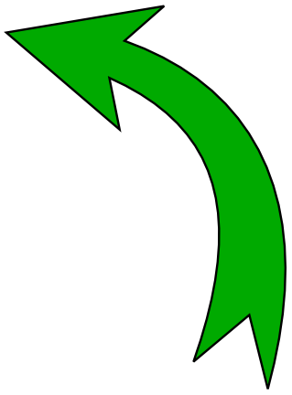

Sample Paragraph:
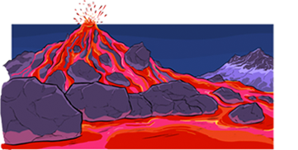
Volcanoes
A volcano is a mountain that opens downward to a pool of molten, or melted, rock below the surface of the Earth. Unlike most mountains, which are pushed up from below, volcanoes are vents through which molten rock escapes to the Earth’s surface. When pressure from gases within the molten rock becomes too great, an eruption occurs. Eruptions can be quiet or explosive. There may be lava flows, flattened landscapes, poisonous gases, and flying rock and ash that can sometimes travel hundreds of miles downwind. Because of their intense heat, lava flows are great fire hazards. Lava flows destroy everything in their path, but most move slowly enough that people can move out of the way.
http://www.ready.gov/kids/know-the-facts/volcano

Go Back to the Text
After reading the article, answer the following questions about the text. Remember to GO BACK to the text to find evidence to support your answer!

Question #1: _______________________________________________________
Answer: __________________________________________________________________
__________________________________________________________________

How do you know? “Go back! Go back! Go back and find where it belongs!”
________________________________________________________________________________________________________________________________________________________________________________________________________________________________________________________________________

Question #2: _______________________________________________________
Answer: __________________________________________________________________
__________________________________________________________________

How do you know? “Go back! Go back! Go back and find where it belongs!”
________________________________________________________________________________________________________________________________________________________________________________________________________________________________________________________________________

